Key Concepts of “avoir” (to have) Unit 2 Lesson 2B nom: _________________________________

- Conjugate the verb “avoir”:

Avoir (to have)

- Explain the difference between pronouncing ILS/ELLES ONT and ILS/ELLES SONT:

- Explain the difference between these two sentences:

J’ai un cours difficile. Je n’ai pas de cours difficile.

- What is an idiomatic expression?

- Explain this slide to a partner. Then, write an explanation in your own words.
Your explanation: ________________________________________________________________________

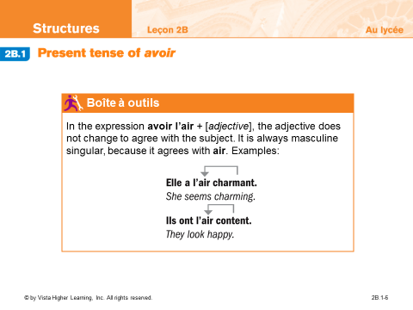

- You are responsible for learning these idiomatic expressions with “avoir”:
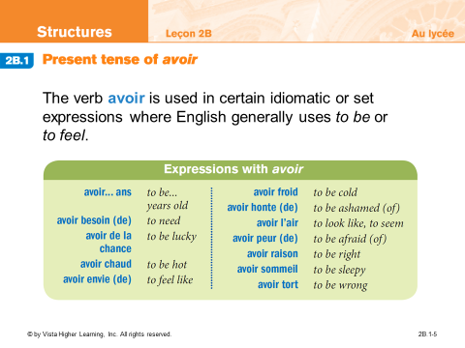
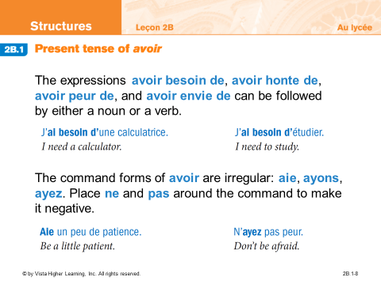
Say one thing you need: _________________________________________________

- Complete this exercise:

