French I Semester I Final Exam Review Guide

In class, we will be doing the following activities: Listening Comprehension Practice, Speaking Practice, contextual usage of this semester’s concepts, grammar practice.

At home, you should do the following to prepare: practice the lists on Quizlet, practice the Kahoots that are found on the main page of my website, complete assigned review activities.

Here is a list of the concepts we have covered in the first semester:

- Nouns and articles (definite and indefinite)
- Numbers 0 – 100
- The verbs être and avoir
- Regular –er verbs
- Adjective agreement
- Forming questions
- Expressing negation
- Telling time
- Descriptive adjectives
- Possessive adjectives

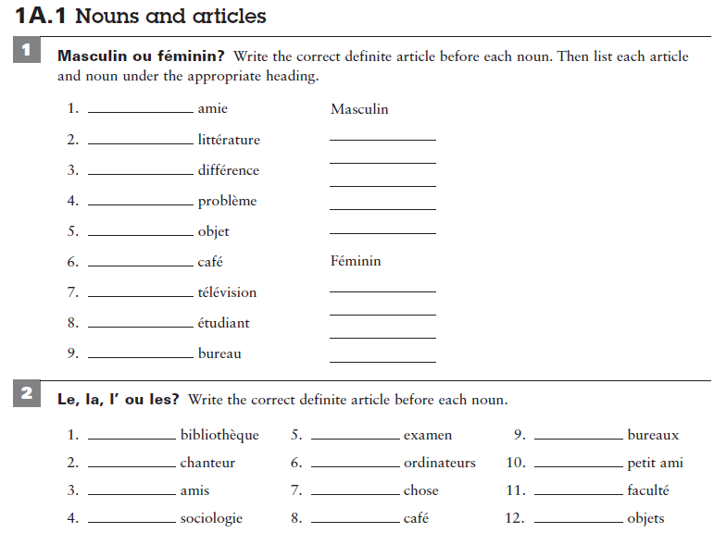

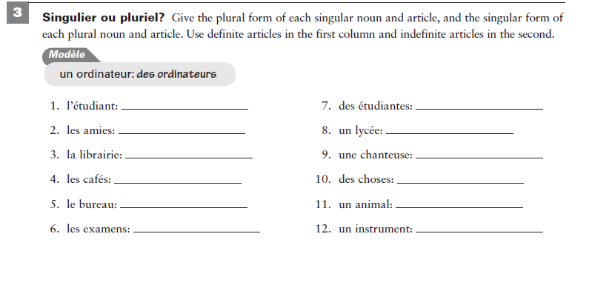

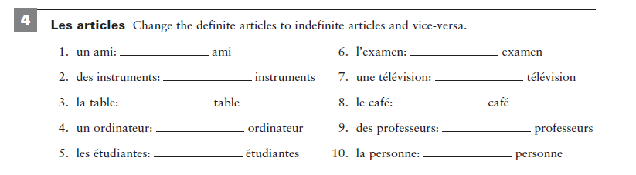

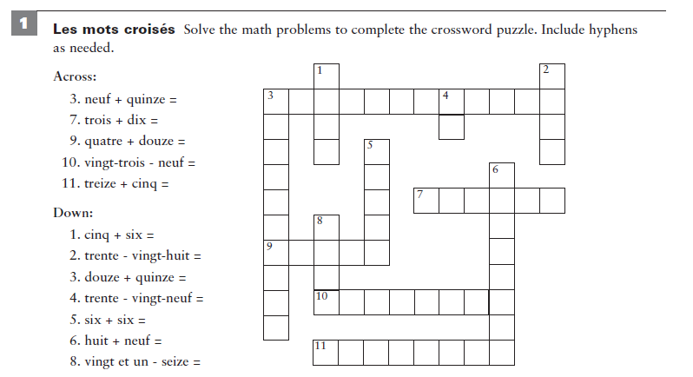

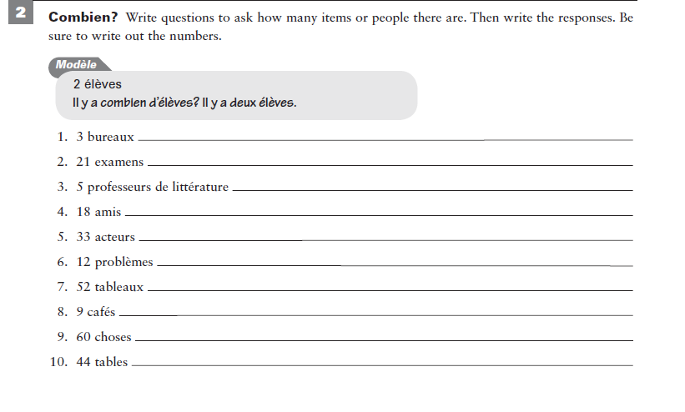

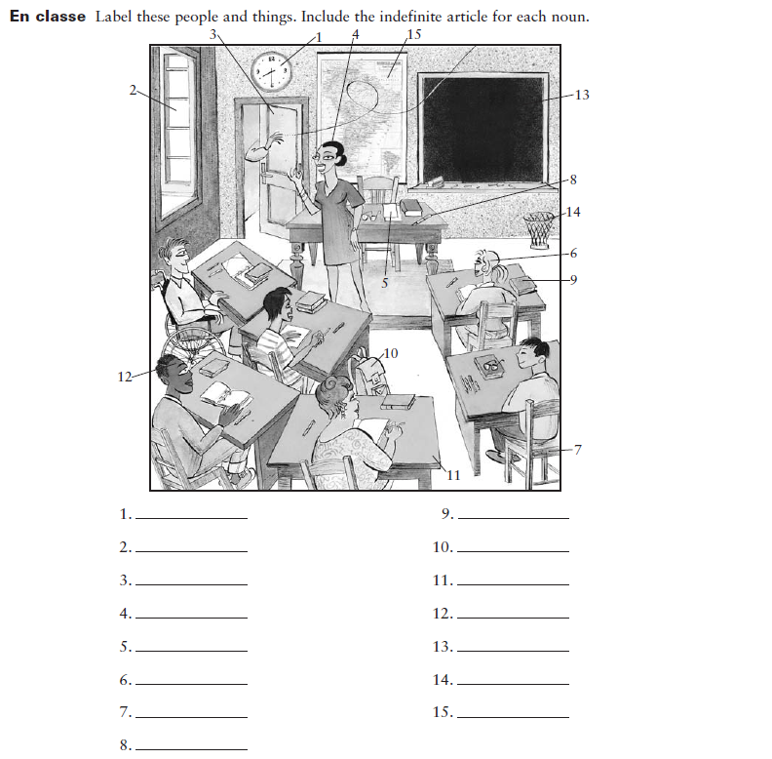

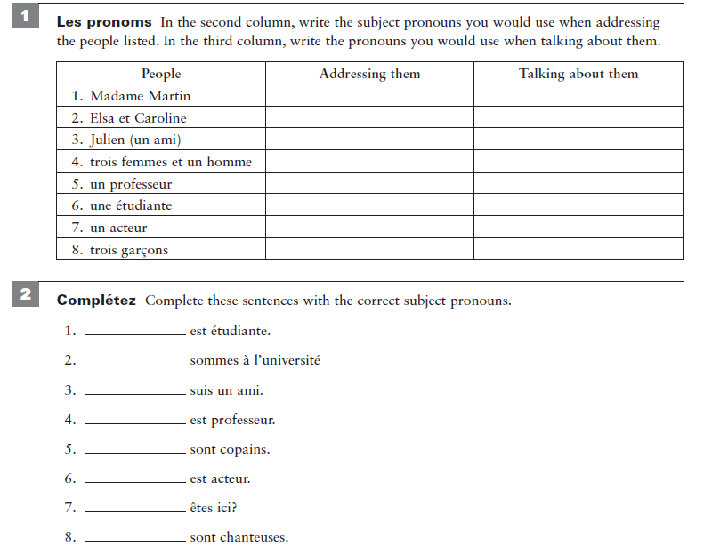

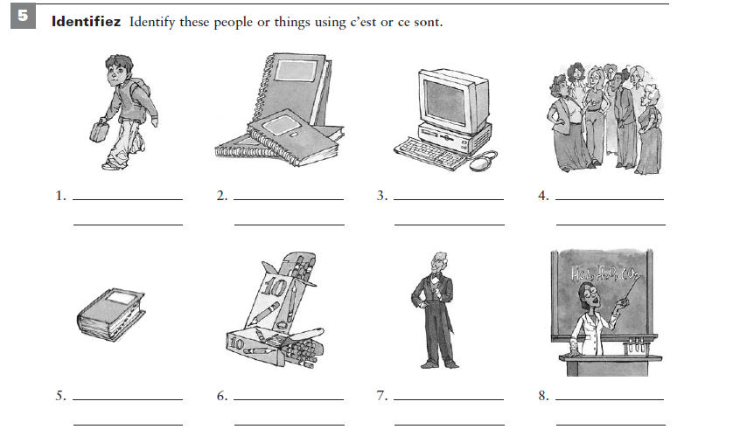

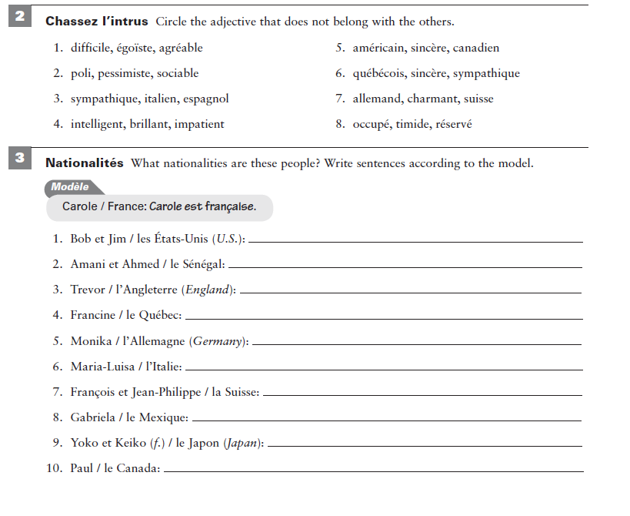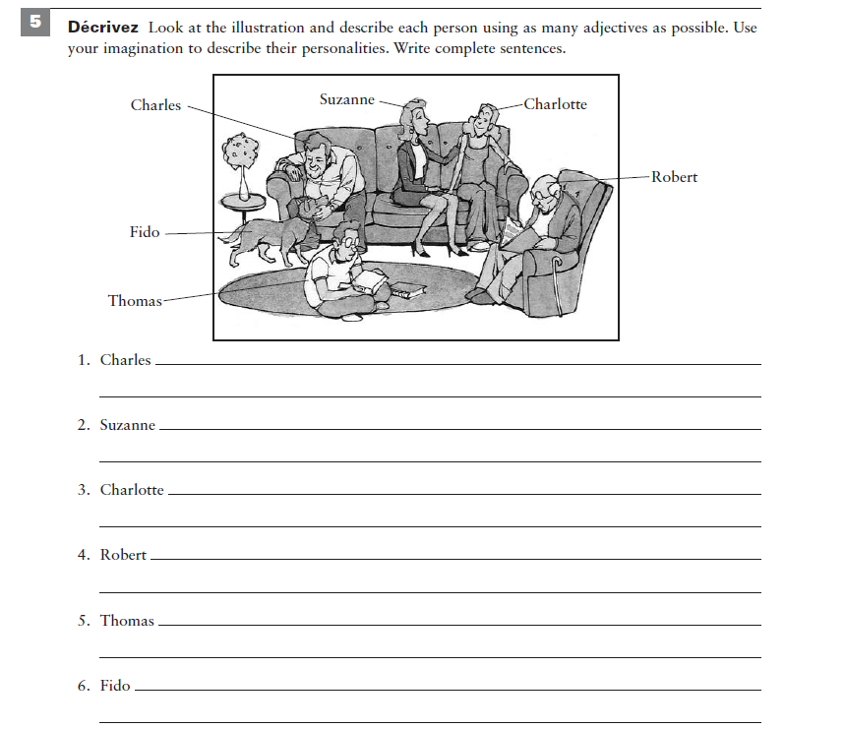

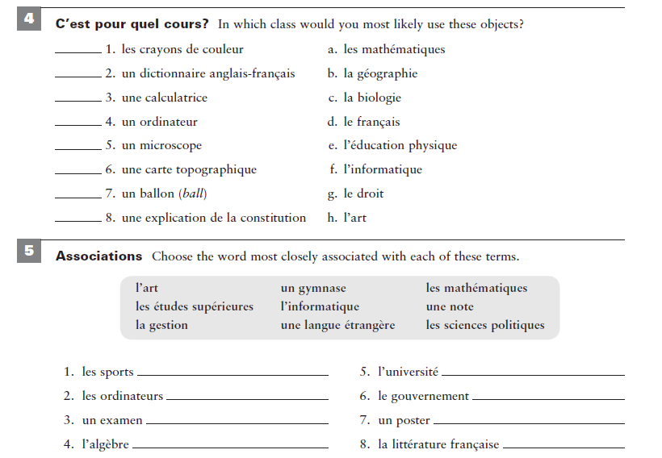889

